CDA 4203L

Computer System Design Lab

Lab 1 Report

ALU Design

|  |  |
| --- | --- |
| Today’s Date: | 1/21/18 |
| Your Name: | Boyang Wu |
| Your U Number: | U95035892 |
| No. of Hours Spent: | 6 |
| Exercise Difficulty:  (Easy, Average, Hard) | Average |
| Any Other Feedback: | Somewhat tricky since I had to get used to the ISE Editor first, also had some other issues with 4-bit. Not too hard once everything was figured out. |

Question 1: ALU Schematic

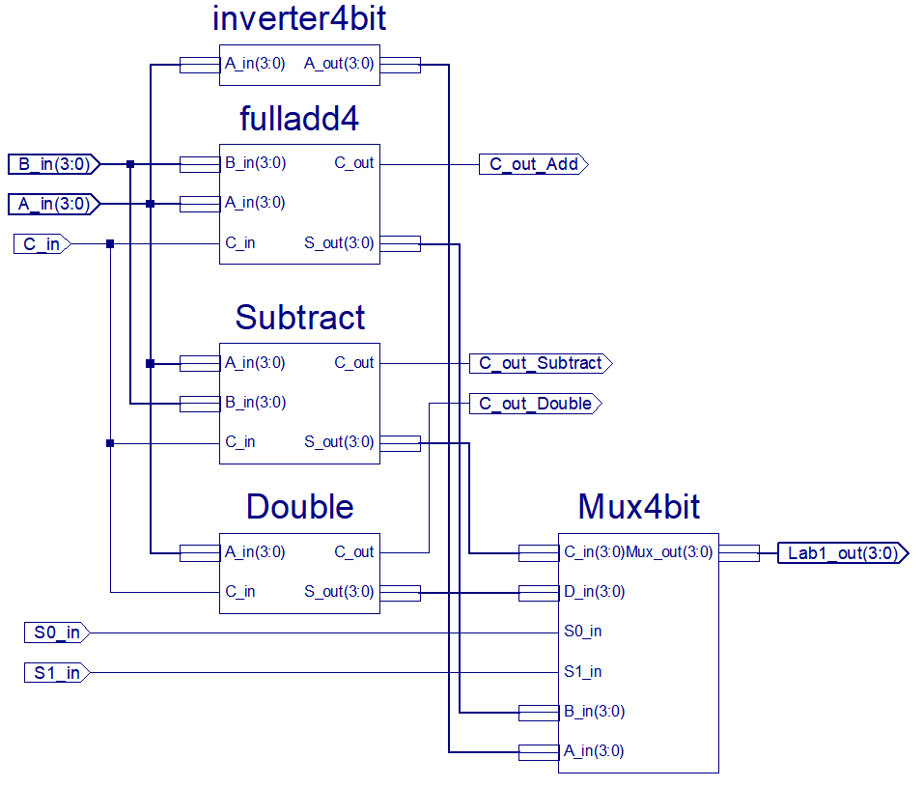

Question 1: Briefly describe how your design works.

1. 4-bit Full adder was from Tutorial 1
2. 4-bit Inverter was created by manually putting together 4 inverters and converting from 4-bit to 1-bit and then back (as done in Tutorial 1 with the 4-bit Full Adder)
3. 4-bit Subtractor was created from 4-bit Full Adder with XOR gates for the inputs as well as a carry in of 1 with an inverter (2’s complement)
4. 1-bit Multiplexer was created from a simple 4 inputs connected to 4 AND gates with the S0 and S1 inputs (with a NOT gate for half of those) and finally and OR gate to the final selection
5. 4-bit Multiplexer was created from 4 of the 1-bit multiplexers with bus taps added to convert 4-bits to 1-bit and vice versa (as done in Tutorial 1 with the 4-bit Full Adder)

Question 2: Simulation Waveforms (add as many pages as you need).

**Did this all in the main ALU. Did two tests for each. Can check the waveform at the end or through the uploaded program.

*****START*****

//Start everything = 0 so S_out = 15

B_in = 0;

S0_in = 0;

S1_in = 0;

A_in = 0;

C_in = 0;

//Invert A = 2

#100

S1_in = 0;

S0_in = 0;

A_in = 2;

B_in = 0;

//Invert A = 15

#100

S1_in = 0;

S0_in = 0;

A_in = 15;

B_in = 0;

//Add 3 + 5

#100

S1_in = 0;

S0_in = 1;

A_in = 3;

B_in = 5;

//Add 2 + 10

#100

S1_in = 0;

S0_in = 1;

A_in = 2;

B_in = 10;

//Subtract 14 - 2

#100

S1_in = 1;

S0_in = 0;

A_in = 14;

B_in = 2;

//Subtract 6 - 4

#100

S1_in = 1;

S0_in = 0;

A_in = 6;

B_in = 4;

//Double A = 3

#100

S1_in = 1;

S0_in = 1;

A_in = 5;

B_in = 0;

//Double A = 7

#100

S1_in = 1;

S0_in = 1;

A_in = 7;

B_in = 0;

*****END*****

